**PRACTICAL – 2(7)**

**AiM: Perform following Functionalities of the string: “CHARUSATUniversity”**

* **Find length**
* **Replace ‘H’ by ‘N’.**
* **Convert all character in Uppercase**
* **Extract and print “CHARUSAT” from given string.**

**SOURCE CODE:**

public class Practical2_7 {

    public static *void* main(String[] *args*) {

        String str_1 = "CHARUSAT University";

        System.out.println("Length of String is: "

 + str_1.length());

        String r = str_1.replace("H", "N");

        System.out.println("Updated New String is

(Replace H by N): " + r);

        System.out.println("Upper Case String is: "

 + str_1.toUpperCase());

        String str_2 = str_1.substring(0, 8);

        System.out.println("SubString is: " + str_2);

        System.out.println("\n20DCE019-Yatharth Chauhan");

    }

}

**OUTPUT:**

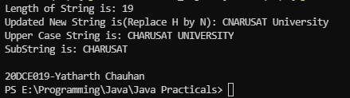

**CONCLUSION:** In this practical we can print the string with any element replaced, upper case of any string and we can also print the substring of any given string.